export PROJECT_ID=deep-mapan

gcloud config set project ${PROJECT_ID}

# gcloud alpha services identity create --service tpu.googleapis.com --project $PROJECT_ID

gcloud beta services identity create --service tpu.googleapis.com --project $PROJECT_ID

（返回 service-PROJECT_NUMBER@cloud-tpu.iam.gserviceaccount.com）

export TPU_NAME="tputest"

export ZONE=europe-west4-a

# export ZONE=us-central1-a

# gcloud alpha compute tpus versions list --zone=$ZONE

# gcloud compute tpus versions list --zone=$ZONE

gcloud compute tpus tpu-vm create tputest \

--zone=$ZONE \

--accelerator-type=v3-8 \

--version=tpu-vm-tf-2.8.0

gcloud compute tpus tpu-vm ssh tputest --zone=$ZONE

# rm -r deep-mapan/

git clone <https://github.com/Devvvi1/deep-mapan.git>

git clone https://github.com/tensorflow/models.git

# export PYTHONPATH="${PYTHONPATH}:/deep-mapan/models"

cd deep-mapan/models

pip3 install -r official/requirements.txt

cd research

sudo protoc object_detection/protos/*.proto --python_out=.

cp object_detection/packages/tf2/setup.py .

python3 -m pip install --upgrade pip

sudo python3 -m pip install .

export PYTHONPATH=$(pwd)

export PYTHONPATH="${PYTHONPATH}:/models"

''''''''''''''''''''''''''''''''''''''''''''''''''''' my code '''''''''''''''''''''''''''''''''''''''''''''''''''''

python3 -m official.vision.modeling.decoders.fpn_test

python3 -m official.vision.modeling.heads.instance_heads_test

python3 -m official.projects.deepmac_maskrcnn.modeling.heads.instance_heads_test

python3 -m official.projects.deepmac_maskrcnn.modeling.maskrcnn_model_test

python3 -m official.common.distribute_utils_test

python3 -m orbit.standard_runner_test

python3 -m orbit.controller_test

''''''''''''''''''''''''''''''''''''''''''''''''''''' my code '''''''''''''''''''''''''''''''''''''''''''''''''''''

exit

gcloud compute tpus tpu-vm delete tputest \

--zone=$ZONE

gcloud compute tpus execution-groups list --zone=$ZONE

git add .

git commit -m

git push -u origin main

下载checkpoint：

Backbone 模型是 ResNet-50，RetinaNet 从主干的预训练检查点开始

wget https://storage.googleapis.com/cloud-tpu-checkpoints/vision-2.0/resnet50_imagenet/checkpoint

wget https://storage.googleapis.com/cloud-tpu-checkpoints/vision-2.0/resnet50_imagenet/ckpt-28080.data-00000-of-00001

wget https://storage.googleapis.com/cloud-tpu-checkpoints/vision-2.0/resnet50_imagenet/ckpt-28080.index

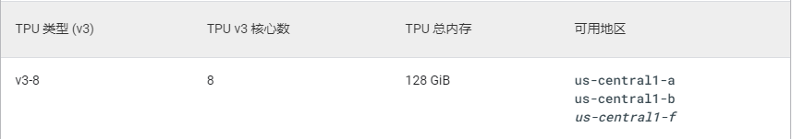

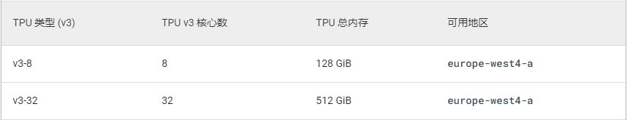



us-central1-a  
us-central1-b  
us-central1-f

europe-west4-a

sudo python3 -m pip install --use-feature=2020-resolver .

python3 object_detection/builders/model_builder_tf2_test.py

python3 -m pip install --upgrade pip

export PYTHONPATH="${PYTHONPATH}:/models”